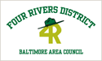
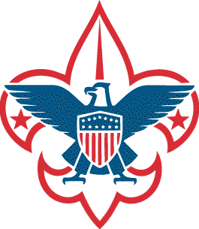
News Release
Media Contact: Steve Mavica | 443-758-8132 | 443-962-2092 | usnpao@hotmail.com

Anne Arundel County Boys Scouts collect over 11 tons of food for local area pantries

GLEN BURNIE, MD (April 28, 2014) – The Boy Scouts of America Four Rivers District completed its Scouting for Food drive this month collecting over 22,000 pounds of food for local community pantries helping to ensure food is available to those in need throughout the summer.

Scouting for Food is one of the Boy Scouts of America’s best known national service projects and is supported by every Boy Scout Council across the nation. First conducted in 1988, this National Good Turn food drive collected 60 million food items in that year alone!

In the Baltimore Area Council, Scouting for Food has a long tradition of being the single largest service project in Central Maryland. For over three decades, Anne Arundel County Boy Scouts of all ages, under adult volunteer leader supervision, have collected non-perishable food items donated from their neighborhoods to help feed families in need and support the homeless.

According to Jim Krempel, Four Rivers District Vice Chair for Programs and this year’s Scouting for Food Chairman, the annual food drive takes place during the month of April when Anne Arundel County boys age 7-18 from almost thirty Cub Scout Packs and Boy Scout Troops of the Four Rivers District deliver empty bags to area homes. Residents are asked to fill the bag with non-perishable food items and place the bag on the front steps or porch for pick-up on a given date.

“I continue to be impressed by the dedication, hard work and enthusiasm I regularly see from the Four Rivers District Scouts. These boys represent our future leaders,” Krempel said. “I couldn’t be prouder of those who helped make this year’s Scouting for Food campaign an incredible success. The program continues to grow as more scouts want to get involved and help those less fortunate."

This year, the Four Rivers District units collecting 1000 pounds or more of donations were:
- Pack 127 (Church of the Holy Apostles, Gambrills) 4643 lbs.
- Troop 382 (Asbury United Methodist Church, Arnold) 2599 lbs.
- Pack 994 (Cape Arthur Improvement Association, Severna Park) 2498 lbs.
- Pack 2214 (Cape St. Claire Improvement Association) 1136 lbs.
- Pack 662 (First Evangelical Lutheran Church, Odenton) 1050 lbs.
- Pack 887 (Marley Elementary School, Glen Burnie) 1000 lbs.

After the collection, Scout youth and adult volunteers gathered, sorted, boxed, and deliverd the donations to several community food banks including the Anne Arundel County Food and Resource Bank, the Christian Assistance Program, My Brothers Pantry, the North County Emergency Outreach Network, Sarah’s House, Serving People Across Neighborhoods, and several individual church food pantries.

In a true community effort, the Anne Arundel County Food Bank provided Scouts with boxes, pallets, and supplies; J.J. Haines Company generously provided Boy Scout volunteers with the use of their Glen Burnie warehouse facility; and the Pitt-Ohio Company provided a truck and driver to deliver palletized donations to the County Food Bank.

###
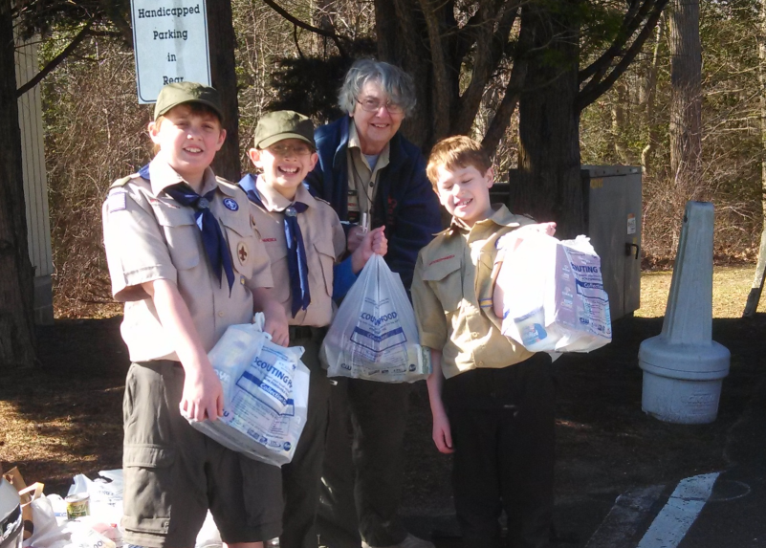
Scouts from Troop 382 collect neighborhood donations (Photo by Chris Nemarich)

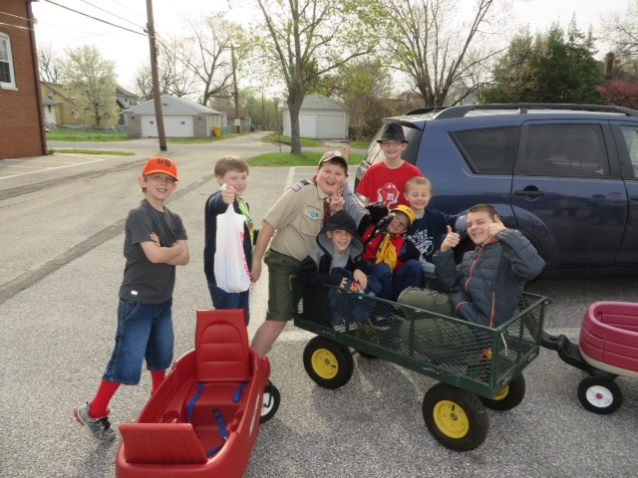
Cub Scouts from Pack 725 collecting donations in Glen Burnie (Judy VanHorn)

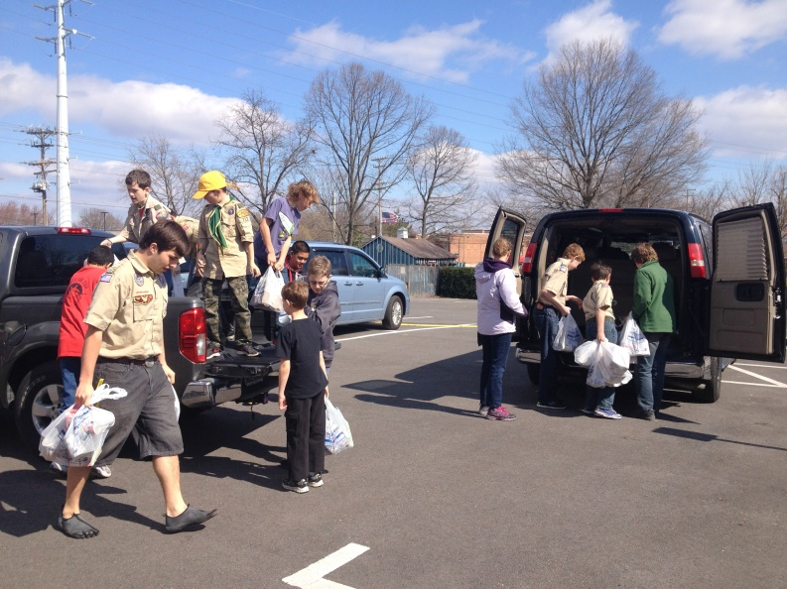
Members of Troop 769 help unload donations collected by Troop 712 (Photo by Lanette Lanfear)
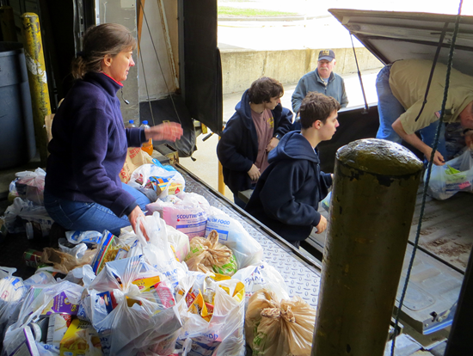
Boy Scouts from Troop 995 unload incoming donations (Photo by Denise Bach)

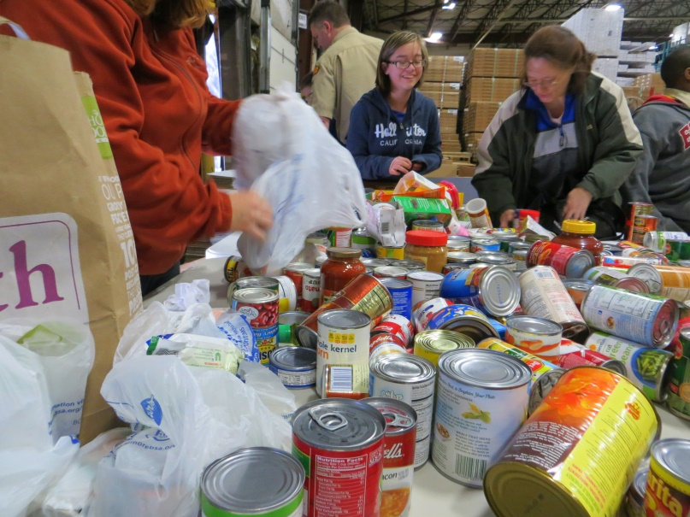
Four Rivers District volunteers sort donations at the J.J. Haines Warehouse (Photo by Denise Bach)

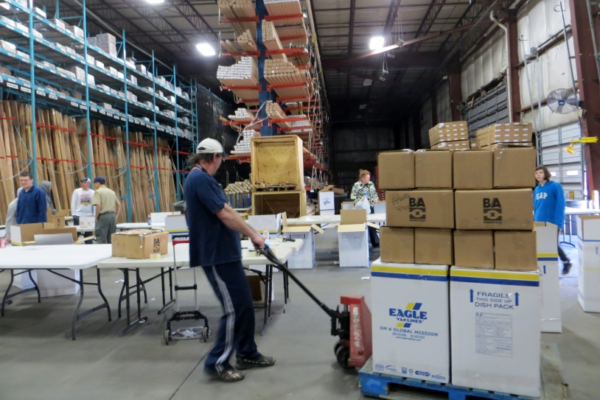
Volunteers palletize donations for delivery by Pitt-Ohio to the County Food Bank (Photo by Jim Krempel)

